**Predicting the Survival of Titanic Passengers**

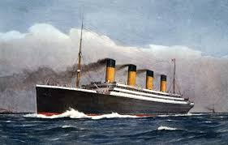

***RMS TITANIC:***

RMS Titanic was a British passenger [liner](https://en.wikipedia.org/wiki/Ocean_liner) operated by the [White Star Line](https://en.wikipedia.org/wiki/White_Star_Line) that [sank in the North Atlantic Ocean](https://en.wikipedia.org/wiki/Sinking_of_the_RMS_Titanic) on 15 April 1912, after striking an [iceberg](https://en.wikipedia.org/wiki/Iceberg) during her [maiden voyage](https://en.wikipedia.org/wiki/Maiden_voyage) from [Southampton](https://en.wikipedia.org/wiki/Southampton) to [New York City](https://en.wikipedia.org/wiki/New_York_City).

* In this blog,I will experiment with different machine learning algorithms and build a program that can predict whether a given passenger would have survived this disaster or not according to Pclass, sex, age  etc

**Importing necessary library**

**import** **pandas** **as** **pd**

**import** **numpy** **as** **np**

***#Data Visualization***

**import** **matplotlib.pyplot** **as** **plt**

**import** **seaborn** **as** **sns**

***#Importing warnings***

**import** **warnings**

warnings.filterwarnings('ignore')

# *Getting the Data*

df=pd.read_csv('titanic.csv')

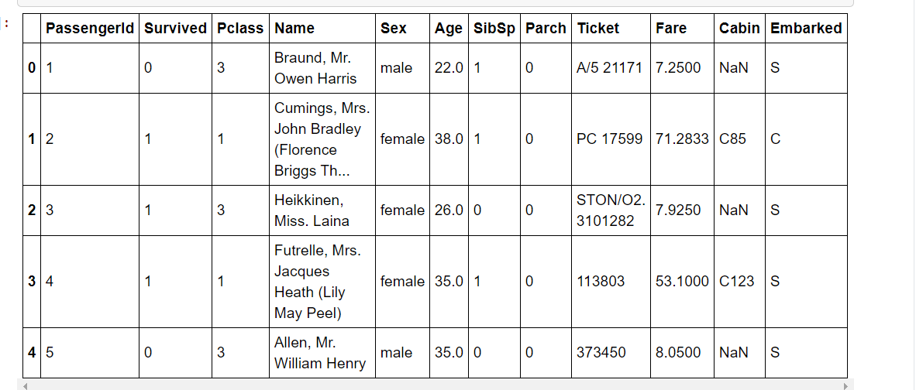df.head()

**Checking shape of dataset.**

df.shape

(891, 12)

In this dataset 891 rows & 12 columns are present,which is describes below:

1.PassengerID:Unique ID of passenger.

2.survived: Survival

(0 = no; 1 = yes)

3.Pclass: Passenger class

(1 = first; 2 = second; 3 = third)

4.Name: Name

5.sex: Sex

6.Age: Age in years

7.sibsp: Number of siblings/spouses aboard

8.parch: Number of parents/children aboard

9.ticket: Ticket number

10.fare: Passenger fare

11.cabin: Cabin number

12.embarked: Port of embarkation (C = Cherbourg; Q = Queenstown; S = Southampton)

# *Data Exploration/Analysis*

<class 'pandas.core.frame.DataFrame'>

RangeIndex: 891 entries, 0 to 890

Data columns (total 12 columns):

# Column Non-Null Count Dtype

--- ------ -------------- -----

0 PassengerId 891 non-null int64

1 Survived 891 non-null int64

2 Pclass 891 non-null int64

3 Name 891 non-null object

4 Sex 891 non-null object

5 Age 714 non-null float64

6 SibSp 891 non-null int64

7 Parch 891 non-null int64

8 Ticket 891 non-null object

9 Fare 891 non-null float64

10 Cabin 204 non-null object

11 Embarked 889 non-null object

dtypes: float64(2), int64(5), object(5)

memory usage: 83.7+ KB

**Observation:**

1.It has 11 features & 1 target column (survived).

2.Age & Fare are floats

3.PassengerID,Survived,Pclass,sibsp,parch are integers

4.Name,sex,Ticket,cabin,embarked are objects.

**Now we check description of numerical column**

df.describe()

|  | **PassengerId** | **Survived** | **Pclass** | **Age** | **SibSp** | **Parch** | **Fare** |
| --- | --- | --- | --- | --- | --- | --- | --- |
| **count** | 891.000000 | 891.000000 | 891.000000 | 714.000000 | 891.000000 | 891.000000 | 891.000000 |
| **mean** | 446.000000 | 0.383838 | 2.308642 | 29.699118 | 0.523008 | 0.381594 | 32.204208 |
| **std** | 257.353842 | 0.486592 | 0.836071 | 14.526497 | 1.102743 | 0.806057 | 49.693429 |
| **min** | 1.000000 | 0.000000 | 1.000000 | 0.420000 | 0.000000 | 0.000000 | 0.000000 |
| **25%** | 223.500000 | 0.000000 | 2.000000 | 20.125000 | 0.000000 | 0.000000 | 7.910400 |
| **50%** | 446.000000 | 0.000000 | 3.000000 | 28.000000 | 0.000000 | 0.000000 | 14.454200 |
| **75%** | 668.500000 | 1.000000 | 3.000000 | 38.000000 | 1.000000 | 0.000000 | 31.000000 |
| **max** | 891.000000 | 1.000000 | 3.000000 | 80.000000 | 8.000000 | 6.000000 | 512.329200 |

Some Observation:

1.There are a total of 891 passengers in our dataset

2. there are very less mean value for the survived ,it means very less people survived

3.the mean of age are around 30,it means maxm middle age people were travelling

4.For age minm value is 0.42,it means some infants were also travelling (of few months).

5.We also notice that age contains some missing values.

**Column names:**

['PassengerId', 'Survived', 'Pclass', 'Name', 'Sex', 'Age', 'SibSp',

'Parch', 'Ticket', 'Fare', 'Cabin', 'Embarked']

# *Now we will try to find 0ut,******What features could contribute to high survival rate****?***

# First we check correlation between the columns.

# check corelation

plt.figure(figsize=(12,8))

sns.heatmap(df.corr(),annot=**True**)

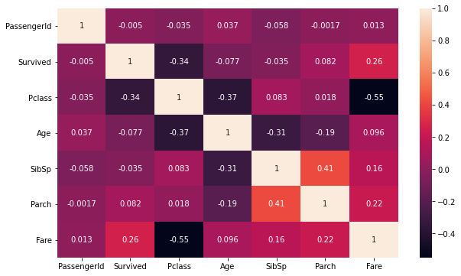

Now we check correlation with the target variable .ie survived.

*#Checking correlation with the taget variable .ie num*

plt.figure(figsize=(8,6))

df.drop('Survived',axis=1).corrwith(df['Survived']).plot(kind='bar',grid=**True**)

plt.xticks(rotation=20)

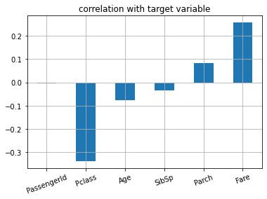

Observation:

1.survived is very very less correlated with passengerId

2.Survived is positively correlated with Parch & Fare

3.Survived is negatively correlated with Pclass,Age,Sibsp

# Now we perform some DATA VISUALIZATION

# Survived.

sns.countplot(x='Survived',data=df)

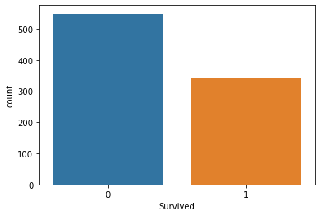

From above graph we find that no. of survived people is very less than that of not survived

Survived vs sex

sns.countplot(x='Survived',data=df,hue='Sex')

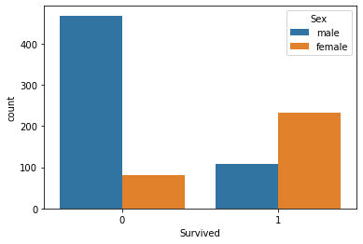

From above plot is is clear that out of the total male very few survived,while on the other hand most of the female survived.

Checking Age columns

df['Age'].plot.hist()

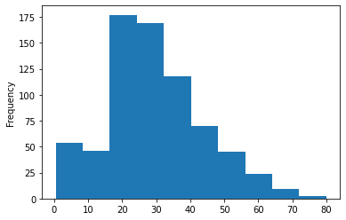

It shows more middle age people are travelling on titanic.

**#checking people of which age range maximum**

**survived**

plt.hist(x='Age',bins=range(0,110,10),data=df.loc[df['Survived']==1])

plt.show()

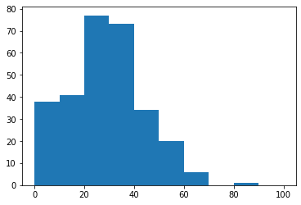

It shows around 78 people of age b/w 20-30 survived

# Age vs survived

sns.violinplot(x='Sex',y='Age',hue='Survived',data=df,split=True)

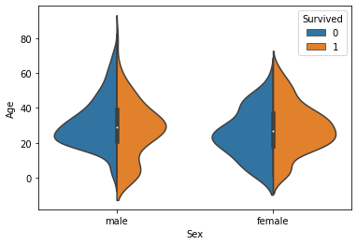

**This graph gives a summary of the age range of men,women & children who were saved.**

**The survival rate is-**

1.Good for children

2.High for women in the age range 20-50

3.Less for men as the age increases

**Pclass vs survived**

sns.barplot(x='Pclass',y='Survived',data=df,hue='Sex')

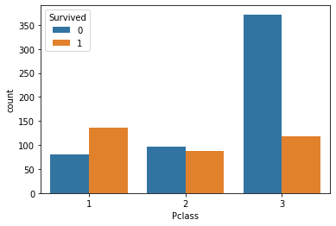

from above graph we find that:-

1.In 1st class ,more people survived than dying

2.In 2nd class no. of people who survived were less but almost equal to not survived

3.In 3rd class no. of people who survived were far less than that who did not survived.

**\* lets check what was the avg fare price for 1st 2nd & 3rd clss people**

**Pclass vs Fare**

sns.barplot(x='Pclass',y='Fare',data=df)

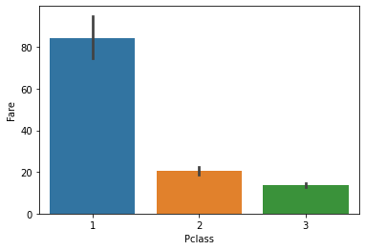

We observe that:

1.For the 1st class which is wealthier class ,the fare is quite higher

2.For 2nd class, fare is low & for 3rd class fare is very very low.

**Checking sibsp column:**

sns.countplot(x='SibSp',data=df)

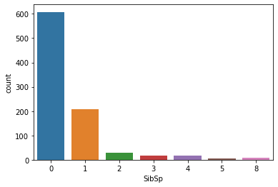

Here sibsp features refers to the number of siblings or spouse the person was accompanied with.

We see that most of the people came alone.

**SibSp vs Survived**

sns.barplot(x='SibSp',y='Survived',data=df)

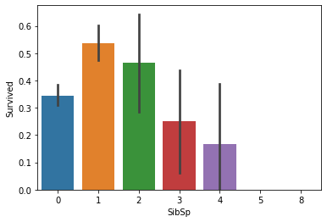

We observe that ,with 1 0r 2 relative ,the chance of survival is more.

**Embarked :**

sns.countplot(x='Embarked',data=df)

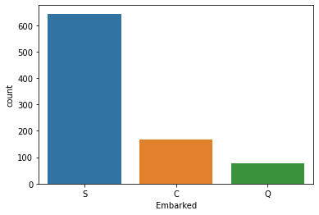

Most of the passenger boarded the ship from port S.

Few passenger boarded from port Q

**Embarked vs survived w.r.t Sex**

sns.barplot(x='Embarked',y='Survived',hue='Sex',data=df)

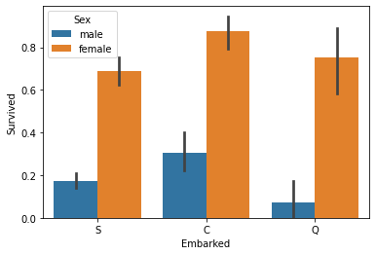

**We observe that:**

1.Women on all the port have a higher chance of survival.

2. Men have a high survival probability if they are on port C, but a low probability if they are on port Q or S.

# Data Preprocessing

# Checking the missing value:

df.isnull().sum()

PassengerId 0

Survived 0

Pclass 0

Name 0

Sex 0

Age 177

SibSp 0

Parch 0

Ticket 0

Fare 0

Cabin 687

Embarked 2

dtype: int64

**#checking the missing percentage**

**df.isnull().sum()*100/len(df)**

PassengerId 0.000000

Survived 0.000000

Pclass 0.000000

Name 0.000000

Sex 0.000000

Age 19.865320

SibSp 0.000000

Parch 0.000000

Ticket 0.000000

Fare 0.000000

Cabin 77.104377

Embarked 0.224467

dtype: float64

**Observation:**

1.The Embarked feature has only 2 missing values, which can easily be filled

2.Age features has 177 missing values,which we will fill

3.The ‘Cabin’ feature has 77 % of missing value.So,we can drop it.

# We can also drop PassengerID,Ticket & Name as it is not of much use.

df.drop(['PassengerId','Name','Ticket',’Cabin’],axis=1,inplace=**True**)

**Imputing null value**

*#SimpleImputer works forimputing null values in object or categorical data*

**from** **sklearn.impute** **import** SimpleImputer

imp=SimpleImputer(strategy='most_frequent')

df['Embarked']=imp.fit_transform(df['Embarked'].values.reshape(-1,1))

im=SimpleImputer(strategy='mean')

df['Age']=im.fit_transform(df['Age'].values.reshape(-1,1))

## **Converting Features:**

**Sex & Embarked features are of object type,which we will convert into numerical datatype**

**from** **sklearn.preprocessing** **import** LabelEncoder

le=LabelEncoder()

list=['Sex','Embarked']

**for** i **in** list:

df[i]=le.fit_transform(df[i].astype(str))

df.head()

***Checking skewness & outliers***

***Checking skewness***

The skewness is a measure of how asymmetrical our data is distributed

If distribution is between -0.5 & 0.5,the distribution is approximately symmetric.

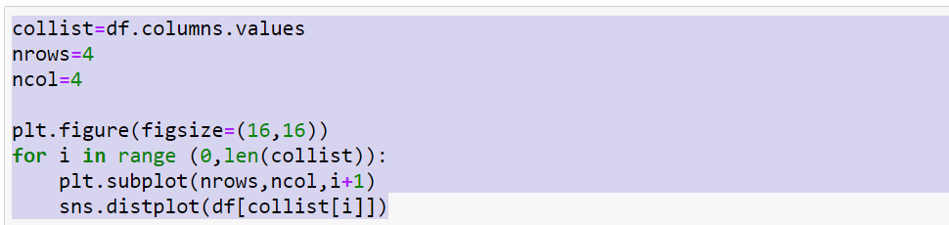

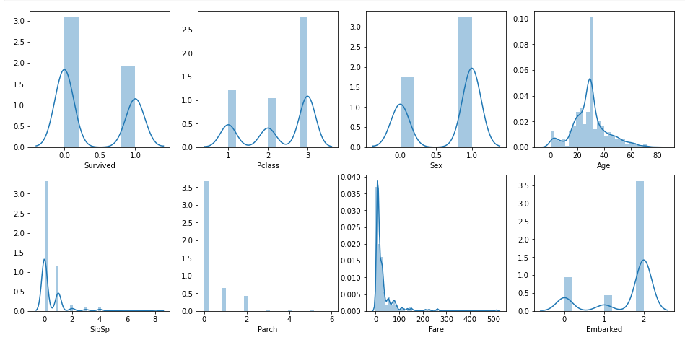

**df.skew()**

Survived 0.478523

Pclass -0.630548

Sex -0.618921

Age 0.434488

SibSp 3.695352

Parch 2.749117

Fare 4.787317

Embarked -1.264823

dtype: float64

we see that the data is skewed,which we need to remove

##treating skewness via squareroot method and cube root method

#treating skewness via squareroot method and cube root method

df.skew()

for col in df.skew().index:

if col in df.describe().columns:

if df[col].skew()>0.55:

df[col]=np.sqrt(df[col])

if df[col].skew()<-0.55:

df[col]=np.cbrt(df[col])

* Again checking skewness

df.skew()

Survived 0.478523

Pclass -0.776838

Sex -0.618921

Age 0.434488

SibSp 1.436526

Parch 1.529799

Fare 2.085004

Embarked -1.520662

dtype: float64

Skewness has been removed

# plotting outliers

Now by using boxplot,we check if outliers are present or not.

**Outliers** are nothing ,but the abnormal data present in the dataset,that deviates from other observation in dataset.

df.plot(kind='box',subplots=**True**,layout=(4,4),figsize=(15,10))

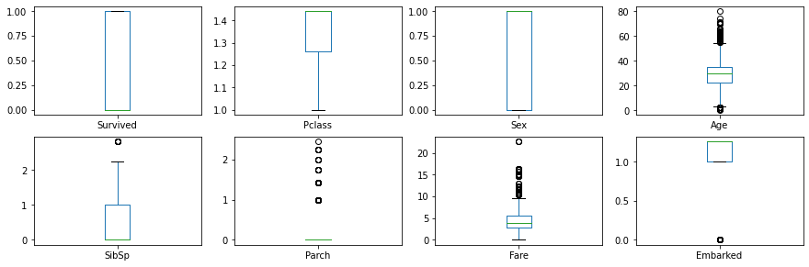

We observe that some outliers are present,which needs to be removed.

# Removing Outliers

**from** **scipy.stats** **import** zscore

z_score=abs(zscore(df))

print(df.shape)

df_new=df.loc[(z_score<3).all(axis=1)]

print(df_new.shape)

(891, 8)

(843, 8)

Outliers has been removed.

Now our dataset is ready to be used as input to a machine learning model.

We see that outliers have been removed.Before, dataset consist of 891 rows & 8 columns.Dataset after removal of outliers contains 843 rows & 8 columns.

*#spliting the data into input and output variable*

x=df_new.iloc[:,1:]

x.shape

(843, 7)

y=pd.DataFrame(df_new['Survived'])

y.shape

(843, 1)

***Scaling the input variable***

We apply standard scaling to make sure that all features are on same scale so that each feature is equally important & make it easier to process by most ML algorithm.

**from** **sklearn.preprocessing** **import** StandardScaler

sc=StandardScaler()

x=sc.fit_transform(x)

# Train_Test_Split

Now let us divide the data into train & test set.

In this project ,I have divided the data into 80:20 ratio

.ie training size is 80% & testing size is 20% of the whole data.

**from** **sklearn.model_selection** **import** train_test_split

x_train,x_test,y_train,y_test=train_test_split(x,y,test_size=.20,random_state=42)

print('x_train_shape:',x_train.shape) print('x_test_shape:',x_test.shape) print('y_train_shape:',y_train.shape) print('y_test_shape:',y_test.shape

x_train_shape: (674, 7)

x_test_shape: (169, 7)

y_train_shape: (674, 1)

y_test_shape: (169, 1)

*#importing our models library*

**from** **sklearn.linear_model** **import** LogisticRegression

**from** **sklearn.tree** **import** DecisionTreeClassifier

**from** **sklearn.svm** **import** SVC

**from** **sklearn.neighbors** **import** KNeighborsClassifier

*#importing metrics*

**from** **sklearn.metrics** **import** accuracy_score,classification_report,confusion_matrix

# logistic regression

max_accuracy_score=0

**for** r_state **in** range(30,100):

x_train,x_test,y_train,y_test=train_test_split(x,y,random_state=r_state,test_size=.20)

lg=LogisticRegression()

lg.fit(x_train,y_train)

lg_pred=lg.predict(x_test)

accuracy_scr=accuracy_score(y_test,lg_pred)

**if** accuracy_scr>max_accuracy_score:

max_accuracy_score=accuracy_scr

final_r_state=r_state

print('max accuracy score corresponding to ',final_r_state,'is',max_accuracy_score)

**max accuracy score corresponding to 89 is 0.8402366863905325**

**KNeighborsClassifier**

**#using GridsearchCV to find the best parmeter in KNeighborsClassifier**

parameters={'n_neighbors':range(22,30)}

knn=KNeighborsClassifier()

clf=GridSearchCV(knn,parameters)

clf.fit(x,y)

print(clf.best_params_)

{'n_neighbors': 26}

**DecisionTreeClassifier**

#using GridsearchCV to find the best parmeter in DecisionTreeClassifier

parameters={'criterion':['gini','entropy'],'random_state':range(42,100)}

dtc=DecisionTreeClassifier()

clf=GridSearchCV(dtc,parameters)

clf.fit(x,y)

print(clf.best_params_)

{'criterion': 'entropy', 'random_state': 59}

**SVC**

In [428]:

#gridsearchcv for svc

parameters={'kernel':['linear','rbf'],'C':[1,10],'random_state':range(35,100)}

svc=SVC()

clf=GridSearchCV(svc,parameters)

clf.fit(x,y)

print(clf.best_params_)

{'C': 1, 'kernel': 'rbf', 'random_state': 35}

#models with is best parameters

lg=LogisticRegression(random_state=89)

knn=KNeighborsClassifier(n_neighbors=26)

svc=SVC(kernel='rbf',C=1,random_state=35)

dtc=DecisionTreeClassifier(criterion='entropy',random_state=59)

#all Algorithm by using for loop

model=[lg,knn,svc,dtc]

for m in model:

m.fit(x_train,y_train)

m.score(x_train,y_train)

predm=m.predict(x_test)

print('Accuracy score of ',m,'is:',accuracy_score(y_test,predm))

print('\n')

print(confusion_matrix(y_test,predm))

print('\n')

print(classification_report(y_test,predm))

print('*************************************************************************************')

print('\n')

Accuracy score of **LogisticRegression**(random_state=89) is: **0.8402366863905325**

[[94 10]

[17 48]]

precision recall f1-score support

0 0.85 0.90 0.87 104

1 0.83 0.74 0.78 65

accuracy 0.84 169

macro avg 0.84 0.82 0.83 169

weighted avg 0.84 0.84 0.84 169

*************************************************************************************

Accuracy score of **KNeighborsClassifier**(n_neighbors=26) is**: 0.8461538461538461**

[[97 7]

[19 46]]

precision recall f1-score support

0 0.84 0.93 0.88 104

1 0.87 0.71 0.78 65

accuracy 0.85 169

macro avg 0.85 0.82 0.83 169

weighted avg 0.85 0.85 0.84 169

*************************************************************************************

Accuracy score of **SVC**(C=1, random_state=35) is: **0.8461538461538461**

[[96 8]

[18 47]]

precision recall f1-score support

0 0.84 0.92 0.88 104

1 0.85 0.72 0.78 65

accuracy 0.85 169

macro avg 0.85 0.82 0.83 169

weighted avg 0.85 0.85 0.84 169

*************************************************************************************

Accuracy score of **DecisionTreeClassifier**(criterion='entropy', random_state=59) is: **0.7514792899408284**

[[84 20]

[22 43]]

precision recall f1-score support

0 0.79 0.81 0.80 104

1 0.68 0.66 0.67 65

accuracy 0.75 169

macro avg 0.74 0.73 0.74 169

weighted avg 0.75 0.75 0.75 169

**Cross Validation**

Cross validation helps to find out the over fitting and under fitting of the model.In the cross validation the model is made to run on different subsets of the dataset which will get multiple measures of the model. If we take 5 folds, the data will be divided into 5 pieces where each part being 20% of full dataset. While running the Cross validation the 1st part (20%) of the 5 parts will be kept out as a hold out set for validation and everything else is used for training data. This way we will get the first estimate of the model quality of the dataset. In the similar way further iterations are made for the second 20% of the dataset is held as a hold out set and remaining 4 parts are used for training data during process. This way we will get the second estimate of the model quality of the dataset. These steps are repeated during the cross validation process to get the remaining estimate of the model quality.

#cross validate the models

models=[lg,knn,svc,dtc]

for m in models:

score=cross_val_score(m,x,y,cv=5,scoring='accuracy')

print('Model:',m)

print('\n')

print('score:',score)

print('mean_score:',score.mean())

print('standard deviation:',score.std())

print('*****************************************************************************************')

print('\n')

**Model: LogisticRegression(random_state=89)**

score: [0.78106509 0.77514793 0.76923077 0.78571429 0.79761905]

mean_score: 0.7817554240631164

standard deviation: 0.009678116247374377

*****************************************************************************************

**Model: KNeighborsClassifier(n_neighbors=26)**

score: [0.81065089 0.80473373 0.78698225 0.79166667 0.82142857]

mean_score: 0.8030924204001127

standard deviation: 0.012538933263509954

*****************************************************************************************

**Model: SVC(C=1, random_state=35)**

score: [0.82840237 0.80473373 0.80473373 0.81547619 0.85714286]

mean_score: 0.8220977740208509

standard deviation: 0.019569217215636692

*****************************************************************************************

**Model: DecisionTreeClassifier(criterion='entropy', random_state=59)**

score: [0.75147929 0.76331361 0.85207101 0.75595238 0.80357143]

mean_score: 0.7852775429698508

standard deviation: 0.03815949253582776

*****************************************************************************************

# Using ensemble technique to boost up our score

# RandomForestClassifier

**from** **sklearn.ensemble** **import** RandomForestClassifier

rf=RandomForestClassifier(n_estimators=50,random_state=42)

rf.fit(x_train,y_train)

predrf=rf.predict(x_test)

print(accuracy_score(y_test,predrf))

print(confusion_matrix(y_test,predrf))

print(classification_report(y_test,predrf,labels=[0,1]))

0.8224852071005917

[[95 9]

[21 44]]

precision recall f1-score support

0 0.82 0.91 0.86 104

1 0.83 0.68 0.75 65

accuracy 0.82 169

macro avg 0.82 0.80 0.80 169

weighted avg 0.82 0.82 0.82 169

# AdaBoost Classifier

**from** **sklearn.ensemble** **import** AdaBoostClassifier

ad=AdaBoostClassifier(n_estimators=50,algorithm='SAMME.R')

ad.fit(x_train,y_train)

ad_pred=ad.predict(x_test)

print(accuracy_score(y_test,ad_pred))

print(confusion_matrix(y_test,ad_pred))

print(classification_report(y_test,ad_pred))

0.8106508875739645

[[90 14]

[18 47]]

precision recall f1-score support

0 0.83 0.87 0.85 104

1 0.77 0.72 0.75 65

accuracy 0.81 169

macro avg 0.80 0.79 0.80 169

weighted avg 0.81 0.81 0.81 169

**AUC ROC CURVE**

ROC curve is nothing but a graph displaying the performance of classification model.

AUC ROC plot is used to visualise the performace of a

binary classifier.

More the aea is under the curve ,better the model is

working.

lgpred_prob=lg.predict_proba(x_test)[:,1]

dtcpred_prob=dtc.predict_proba(x_test)[:,1]

knnpred_prob=knn.predict_proba(x_test)[:,1]

rfpred_prob=rf.predict_proba(x_test)[:,1]

adpred_prob=ad.predict_proba(x_test)[:,1]

**from** **sklearn.metrics** **import** roc_curve

lg_tpr,lg_fpr,lg_thresholds=roc_curve(y_test,lgpred_prob)

dtc_tpr,dtc_fpr,dtc_thresholds=roc_curve(y_test,dtcpred_prob)

knn_tpr,knn_fpr,knn_thresholds=roc_curve(y_test,knnpred_prob)

rf_tpr,rf_fpr,rf_threshold=roc_curve(y_test,rfpred_prob)

ad_tpr,ad_fpr,ad_threshold=roc_curve(y_test,adpred_prob)

plt.plot(lg_tpr,lg_fpr,label='LogisticRegression')

plt.plot(dtc_tpr,dtc_fpr,label ='Decision Tree Classifier')

plt.plot(knn_tpr,knn_fpr,label='KNeighborsClassifier')

plt.plot(rf_tpr,rf_tpr,label='RandomForestClassifier')

plt.plot(ad_tpr,ad_fpr,label='adaboostClassifier')

plt.xlabel('False positive rates')

plt.ylabel('True positive rates')

plt.title('ROC curve for 5 model')

plt.legend(loc='best')

plt.show()

**from** **sklearn.metrics** **import** roc_auc_score

print('LG AUC score',roc_auc_score(y_test,lgpred_prob))

print('DTC AUC SCORE',roc_auc_score(y_test,dtcpred_prob))

print('KNN auc score',roc_auc_score(y_test,knnpred_prob))

print('Random forest classifier',roc_auc_score(y_test,rfpred_prob))

print('Adaboost classifier',roc_auc_score(y_test,adpred_prob))

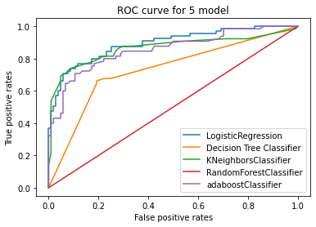

**LG AUC score 0.8926035502958579**

**DTC AUC SCORE 0.7298076923076923**

**KNN auc score 0.8656065088757398**

**Random forest classifier 0.8610946745562131**

**Adaboost classifier 0.8560650887573964**

**Higher the AUC ,better the model is working**

**LogisticRegression can be used to classify ,who survived or not ,or what factors make people more likely to survive.**